 Amazon Pantry

# 

# About:

Amazon Pantry makes it convenient for customers to shop for grocery and household products as it saves time spent in travel, parking, queuing and lugging heavy bags from a store to the car and from there to a customer’s home.

Amazon Panty is a feature of online shopping Amazon, where customers can order "everyday package sizes" of their favorite grocery items — like a single box of banana bread mix or two cans of soup, as well as household items like paper towels and trash bags.

Think ofAmazon Panty as a way to conveniently get all of your dry goods and cleaning supplies. For example, you can't order a gallon of milk, but you can order condensed milk or boxed almond milk.

## 

## Top Section :

Home page -> Login Page -> User Account Page -> Cart Page

## Main Pages:

Cooking and Essentials Page

Snacks and Beverages Page

Packaged Foods

Household & Pets

Personal Care and Baby

Skin Care

Offers

Past Purchases

About page

## Pages Related to particular Item:

Product Detail Page

Buy Page

Payment gateway

Customer Reviews

Filter Section

## Sections Inside Main page:

All the pages listed in main pages section will have a filter section on left which content other items falls under category the particular page.

## Cookings and Essentials page:

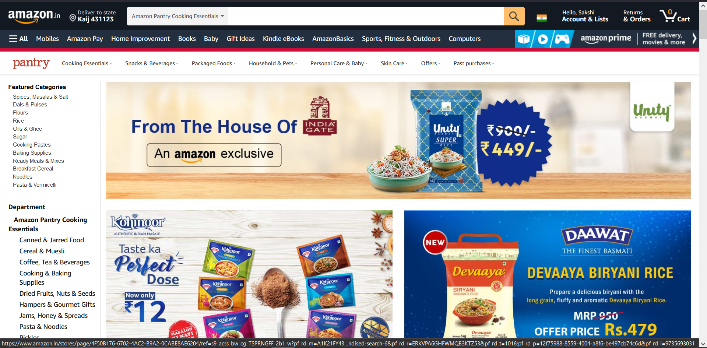

## Snacks and Beverages Page:

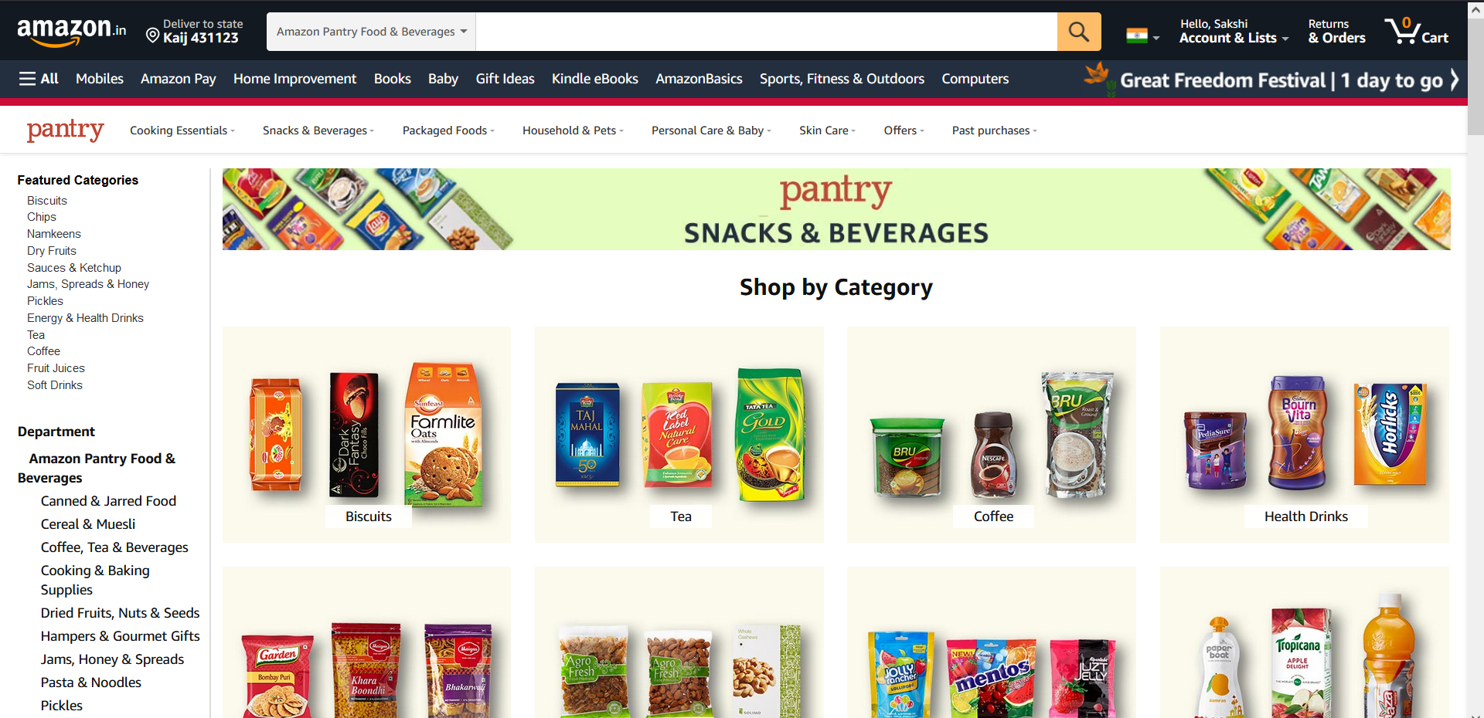

And Other Pages will be same as above

## Technology Stack:

### Front End:

HTML

CSS

React

### BackEnd:

Node JS

### Databases:

MongoDB

Redis

### Payment gateway (UPI, Google Pay, Phone Pay, Paytem)

### Email Server (Gmail)

### Oauth (Login With Google)

### Login/Logout (with Jwt)

### Deployment

Ci/Cd with AWS

Heroku